

**General Engineering Department**

______________________________________________________

**Rapid Assembly & Design (RAD)**

**Final Design Report**

______________________________________________________

Force Glove

Grip Sense, Ltd.

**Project Team Members:**

Zachary Kublalsingh

Pedro Lopez Morales

Leonardo Villalobos

Riley Yan

1. INTRODUCTION

The force glove being designed aims to help gym-goers recognize and correct muscle imbalances, prevent injuries and improve performance. A study conducted by the National Center for Health Statistics stated that “In 2020, 35.2% of men and 26.9% of women aged ≥18 years met the federal guideline for muscle-strengthening physical activity. The percentage of men who met the muscle-strengthening guideline decreased with age” (National Library of Medicine, 2020). This indicates that younger adults, particularly those between ages 18 and 44, are the most engaged in weight lifting. This demographic aligns with the primary market for this product– individuals actively seeking to optimize workouts and prevent injuries. There is no shortage of willingness to invest in self-improvement in America, this is supported by an article published by My Protein in 2020 stating “The average American adult spends $155 per month on their health and fitness – that’s an average of $112,000 in their lifetime! " (My Protein, 2020). This significant expenditure suggests that Americans express a desire to invest in products that enhance fitness routines and prevent injury, making this product a viable market addition.

Injuries are no surprise in the world of fitness. The lack of proper form or load distribution are leading factors for these injuries. A study published by the National Library of Medicine stated, “About 27% of participants had a weight lift injury during the last six months.” (National Library of Medicine, 2023). This statistic highlights that a significant percentage of fitness participants are not practicing safe training parameters. Muscle imbalances are a cause of many injuries in the fitness space. A study published by peloton highlights the consequences of muscle imbalances, “If a joint that is not positioned properly due to a muscle imbalance is then forced to perform, it is more likely to lead to inflammation, impingement, and other soft tissue injuries.” (Peloton, 2024). This study emphasizes how neglecting balanced muscle development creates vulnerabilities to getting injured, illustrating the direct impact muscle imbalances have on the body.

While there are products on the market that track force distribution of the hand, these products are not specific to weightlifting, rather these products are tailored to the ergonomics while using hand tools. The data discussed strongly supports the necessity of a product that helps fitness enthusiasts monitor force distribution during weight training. By leveraging sensor technology and providing user-friendly feedback, this product enhances workout efficiency, prevents injuries, and improves long-term fitness goals.

The landscape of smart gloves reveals a market with varying degrees of accessibility and transparency. Examining three existing products, the PureCarbon Delta Gloves, the Tactile Glove System, and the Shape.Care Sensor Gloves, alongside the design being developed, provides insight into the current state of this technology. The PureCarbon Delta Gloves, although initially promising with an early buyer cost of $99 and a retail price of $199, ultimately failed due to an unsuccessful crowdfunding campaign and the subsequent closure of PureCarbon (Venture Beat, 2017). Conversely, the Tactile Glove System and the Shape.Care Sensory Gloves lack publicly available pricing, requiring potential customers to request quotes. This lack of price transparency creates a barrier to entry, making it difficult for consumers to compare options. Of the three gloves only the Tactile Glove System was the only to have a material listing: TactileGlove Pair, BLE, Module and Housing, BLE USB Dongle, USB Charging Cable, and 65 sensors within the inside of the glove (Pressure Profile, 2023). Similar to price, this lack of material transparency also creates a barrier to entry.

The proposed design offers a more transparent and accessible approach. With an estimated cost of $153.35, it aligns with the planned retail price of the PureCarbon gloves, placing it within a competitive market range. The material listing, including conducted fabric gloves, thin film pressure sensors, Arduino, and LCD display, provides potential customers with a clear understanding of the product’s components. This transparency is a significant advantage, particularly for users who value understanding the products they use

1.2 Background of the Experiment

The Force Glove is designed to minimize muscle injury and promote balanced muscle development during weightlifting. In bi-lateral exercises such as bench press where both sides of the body perform simultaneously, overtime there will become a tendency for one side of your body to become stronger. In an effort to curb this, a combination of Force Sensitive Resistors (FSRs), Arduino, and wireless data communication is used to monitor and analyze the force exerted by each arm in real time.

The glove allows for the user to have real-time feedback of the force between left and right arms. The FSRs are stitched onto the glove and positioned to detect the force applied through the center of your hand (Figure 1). These readings are read and processed by the Arduino and compare them so that the user can know if the force is equal or not. Bluetooth is used to wirelessly transmit this data to a connected device, where it is visually displayed for the user. This real-time feedback allows the individual to make immediate adjustments during the exercise, ensuring that both arms contribute equally to the movement. This is particularly valuable during the bench press, where one arm may subconsciously take on more load than the other, potentially leading to muscle imbalances or injury over time.

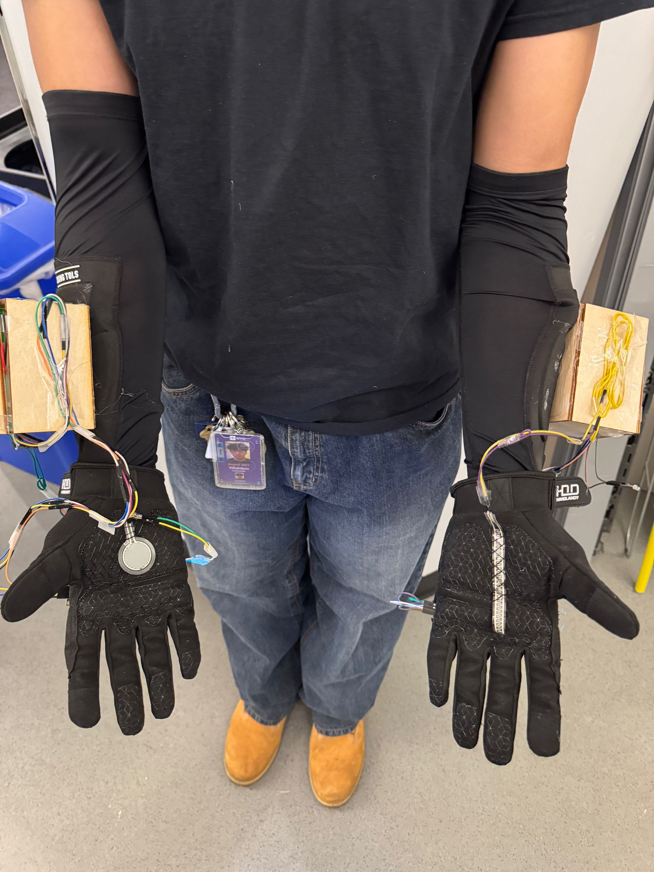

Figure 1: Supinated View of Product

By identifying uneven force distribution during workouts, the user can correct and adjust to optimize the effectiveness of strength training sessions while reducing the risk of injuries.

2. REQUIREMENTS

2.1 Physical Components

The Force Glove is an entire bundle that includes the gloves, and arm sleeves. It consists of multiple components (Table 1) that are attached to the glove and arm sleeve which enable it to be functional. The Arduino, breadboard, Bluetooth module and battery are all housed in a hollow box made from wood to ensure the components are not damaged or disconnected. The measurements of this wooden box are 4.00 x 3.00 inches in length by 4.00 x 2.50 inches in width and 3.00 x 2.50 inches in height.

Table 1. Cost Estimate of The Design

| **Resources** | **Cost per unit** | **Quantity** | **Cost** |
| --- | --- | --- | --- |
| **Gloves: Conductive Fabric Gloves** | $14.80 | 1 | $14.80 |
| **Arm Sleeve** | $14.99 | 2 | $29.98 |
| **Arduino UNO** | $27.60 | 2 | $55.20 |
| **2pc Thin Film Pressure Sensor** | $9.20 | 2 | $18.40 |
| **LCD Display: I2C LCD** | $9.99 | 2 | $19.98 |
| **BreadBoard Jumper Wires** | $7.99 | 1 | 7.99 |
| **BreadBoard(Half size)** | $1.50 | 2 | $3.00 |
| **Birchwood board (12 in. by 12 in.)** | $2.00 | 2 | $4.00 |
| **Labor cost** | $40 | 50 | $8,000 |
| **Total:** |  |  | $8,153.35 |

The FSRs were stitched to the palm of the glove allowing it to have optimal surface area to ensure maximum force was being read. It was attached to the breadboard via a 0.50-inch hole at the front of the box. The wires inside the box were tapped to the breadboard to ensure they were stationary during lifts and the wires on the outside were tapped to the outside of the box to ensure they were stationary also. The breadboard was stuck to the inside of the box on its side to allow for the Arduino to lay flat, to ensure both components did not interfere with each other (Figure 2).

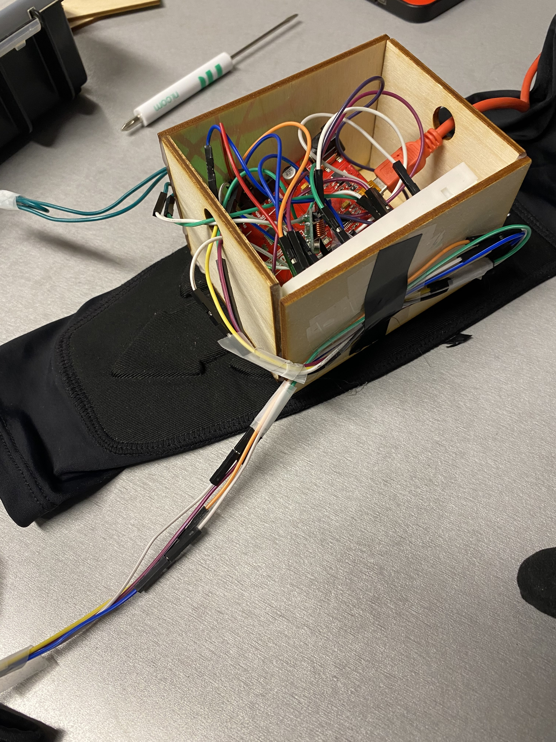

Figure 2: Components Within Housing

2.2 Software Components

The goal of the Force Glove is to take two inputs, from the FSR’s, send them to the Bluetooth module and Arduino so that they can be compared to see if the forces were equal or not. The logic was written in the Arduino IDE which primarily uses C, to make the product more user friendly the LiquidCrystalI2C LCD library was used to allow for the force readings to be read from a LCD which was attached to the back of the glove via Velcro. The wireless module was initialized through the WireUpdate, RadioHead, SPIExtension and Wifi101OTA and library.

3. PROCEDURES

3.1 Physical Construction

The construction of Force Glove involved two LCD displays, two half-size breadboards, two arm sleeves, one pair of conductive fabric gloves, two Arduino Unos, one pack of breadboard jumper wires, two thin film pressure sensors, and two birchwood boards (12.00 in. by 12.00 in.).

The birchwood boards were cut using a laser cutter to create four pieces measuring 4.00 in. by 3.00 in., four pieces messing 4.00 in. by 2.50 in., and four pieces measuring 3.00 in. by 2.50 in. that had a hole measuring 0.50 in. by 0.50 in. centered near the top.

To assemble one casing for the hardware, one 4.00 by 2.50 in. board was laid flat as the base. Along each of the 3.00 in. edges, the two 3.00 by 2.50 in. boards were glued securely to the base using a hot glue gun. A 4.00 by 2.50 in board was attached to connect the two 3.00 by 2.50 in. boards along the 2.50 in. edges of the boards. This process was repeated with another 4.00 by 2.50 in. board on the other 2.50 edge of the 3.00 by 2.50 in. boards. This process was repeated to create another case. Each case was attached to each of the arm sleeves by using a hot glue gun to glue the base of the case onto the arm sleeve.

For each of the cases, one Arduino board was placed flat on the base, along one of the walls. One breadboard was placed sideways, beside the Arduino board (Figure 3). One battery was placed on top of the Arduino board.



Figure 3: Casing Attached to Arm Sleeve with Hardware Inside

For the circuitry for the left glove the FSR, LCD and wireless module are connected to the breadboard and Arduino, the resistors and LEDs are connected to the breadboard only (Figure 4).

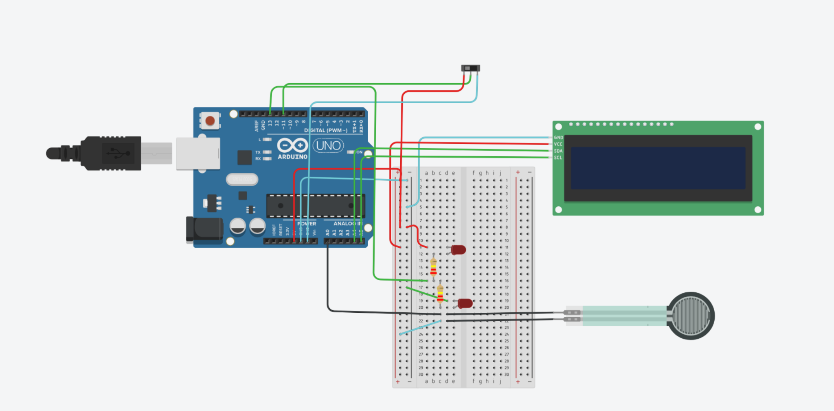

Figure 4: Circuit for Left Glove

For the circuitry for the right glove the FSR, LCD and wireless module are connected to the breadboard and Arduino(Figure 5).

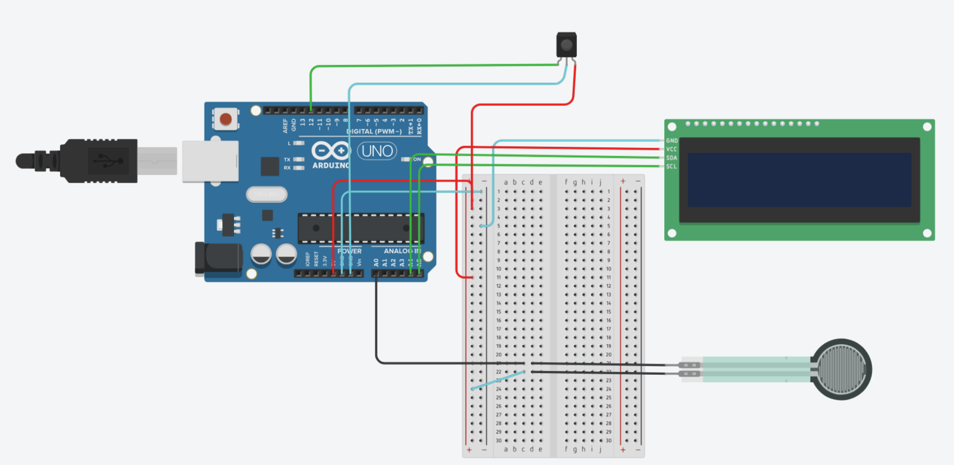

Figure 5: Circuit for Right Glove

For each of the gloves, a velcro strip was attached to the back of a glove, below where the knuckles would be, using a hot glue gun (Figure 5). The opposing velcro strip was attached to the back of a LCD display in several cut parts, using the adhesive side of the velcro (Figure 6).

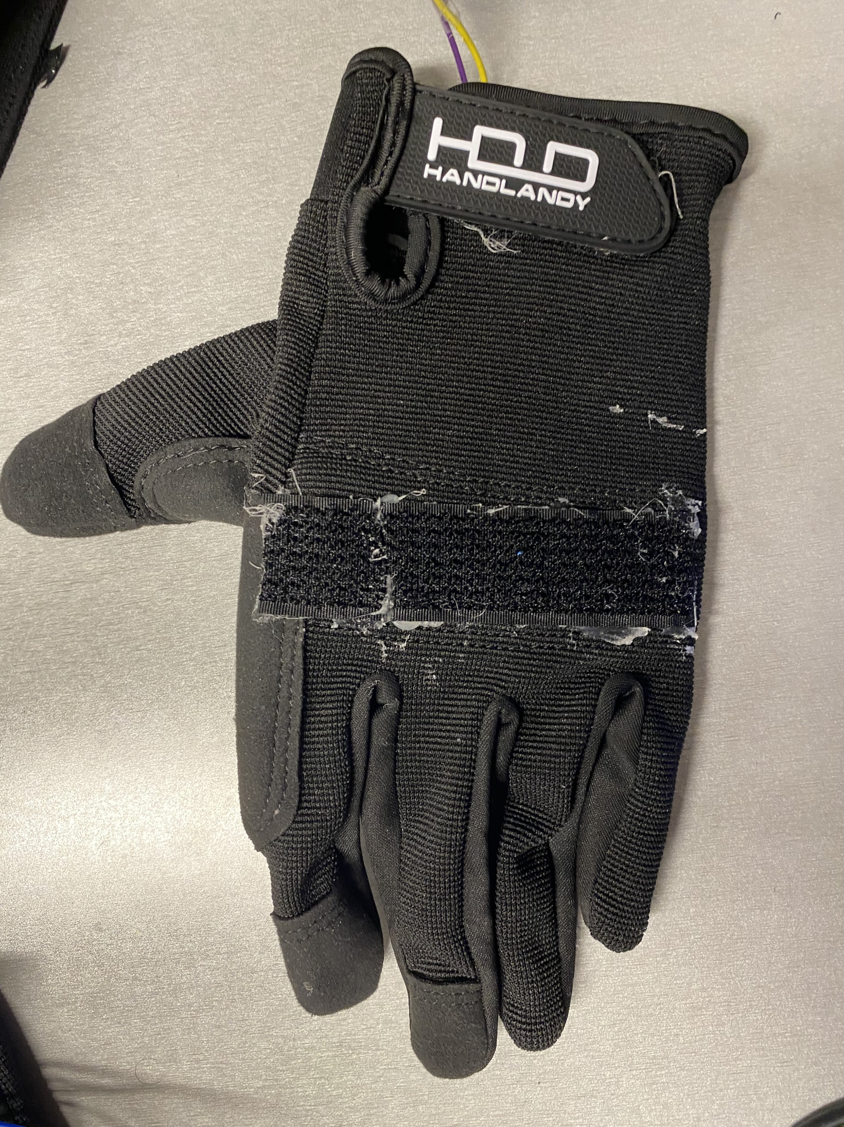

Figure 5: Back of Glove with Velcro Strip Attached

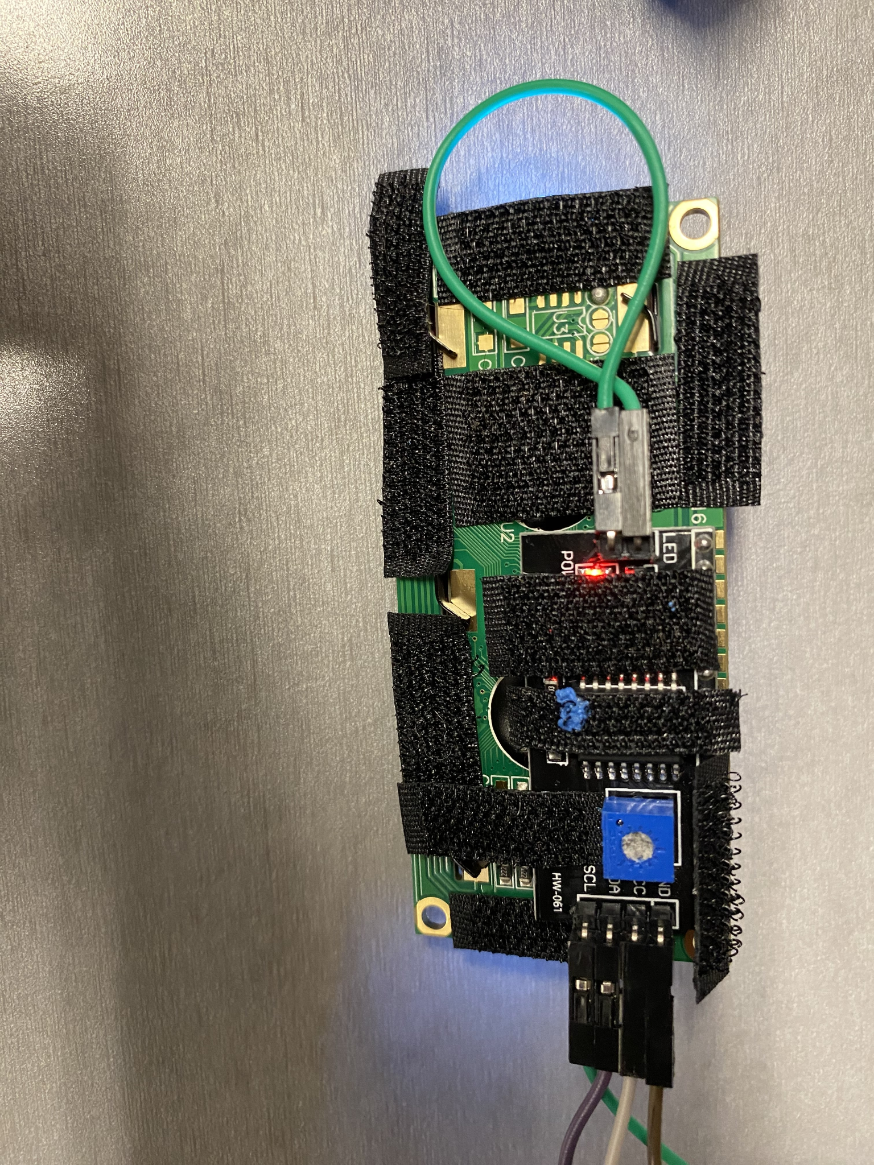

Figure 6: Back of LCD Display with Velcro Strip Attached

For each of the gloves, one FSR was attached to the palm of the glove. The FSR was sewn onto the glove, each thread manually sewed across the FSR to hold it in place (Figure 7).

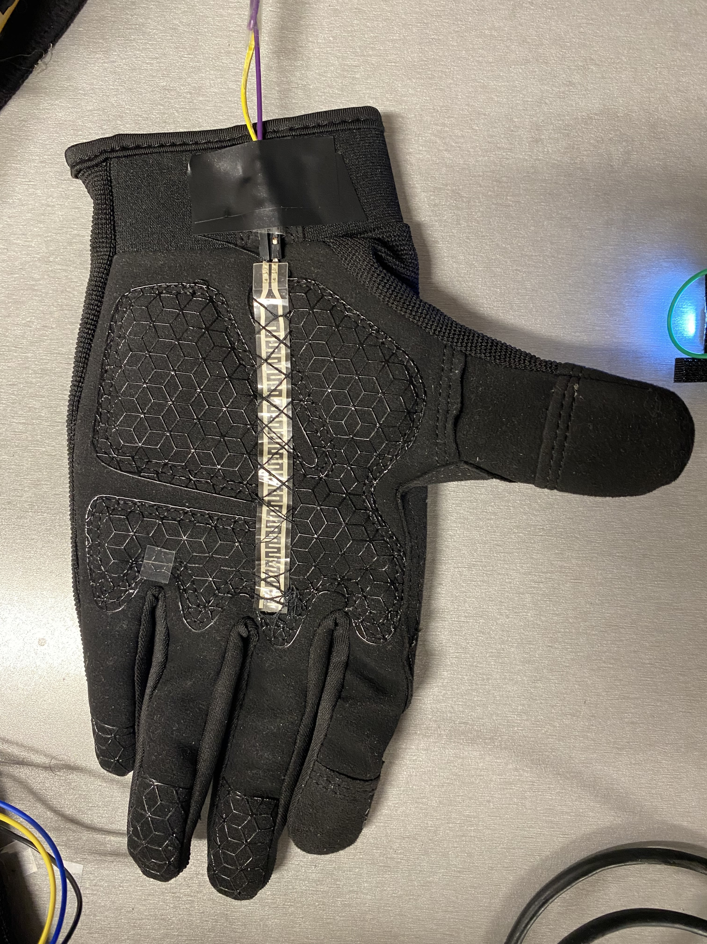

Figure 7: Palm of Glove with FSR Attached

3.2 Software Setup

The software essential for Force Glove was the Arduino IDE. The libraries necessary for this project to work were the LiquidCrystalI2C library for the LCD and the wireless module was initialized through the WireUpdate, RadioHead, SPIExtension and Wifi101OTA and library.for the wireless module. These libraries were installed in the IDE through the library manager and then imported into the code via include statements.

The code was set up so that the right wireless module was the sender and the left module was the receiver and processor. The right module would read the force from the FSR and send it to the left module where the left module would compare its reading to the received reading. If the readings were within 100 Newtons of each other the force would be considered equal and if they differed by 100 Newtons the LED would light and the LCD would indicate where to add more force.

The algorithm for the Force Glove can be represented within a flowchart (Figure 8). After the components were initialized, the Arduino continuously loops to read and compare force readings from the FSRs. When initialized the LCD displays “Left” or “Right” arm ready to indicate to the user that the device is ready for use. Once the glove detects force it will display it on the LCD screen to the user and if they are different the LED will light ensuring it is clear to the user that one side is producing more force than the other.

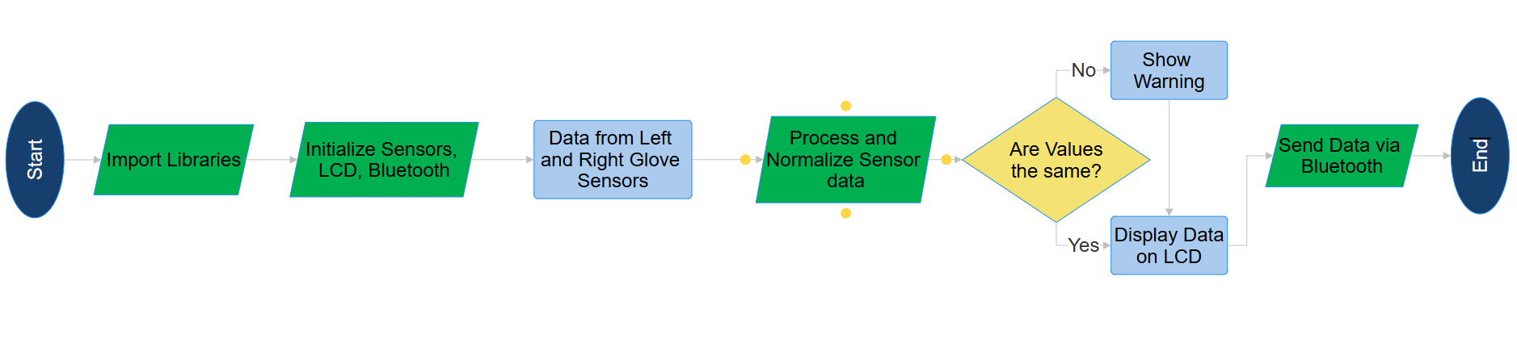

Figure 8: Code Flowchart.

To allow for the product to be accessible on the internet, a website was made displaying an about section, a team section, mission statement and the product with images of the product. The website was made using Next.js, the React Framework and hosted using Vercel.

3.3 Software Troubleshooting

Force detection had an initial poor performance. The two FSRs were capped at different values and responded differently to the same level of force. To aid this, resistors were used as well as calibrating the FSR’s so that the minimum and maximum values were set as the same to ensure the values were identical.

Initially the communication between the Bluetooth modules was an issue because the Bluetooth modules provided were not initializing despite efforts to reset these modules. This led to the switch of using an ESP which acted as the wireless communication for the design.

4. MILESTONE and FINAL PRODUCT REQUIREMENTS

Along the progress of this project there were several benchmark assessments that checked progress. In total there were two benchmarks and one commissioning. A total of three milestone presentations were made for the project during recitation. For each benchmark assessment, a set of tasks were assigned to be completed. These tasks included working parts, presentations, and written work. Along with each benchmark, specific tasks were needed to be completed by the project to benchmark completely. These tasks were assigned by the RAD mentor. At the end of each workshop, all requirements and tasks that were required during the progress of the project were completed and submitted on time.

Benchmark A needed to be completed by the end of model shop 2 to receive full credit. It required several tasks, which included an engineering notebook that contained every task completed until Benchmark A. The notebook needed to contain technical guides and resources that were planned to be used to complete the project. Whenever a task is completed, what was done, who did it, and when it was done should be written down, with pictures uploaded when possible. Each task should have a detailed entry in the notebook, containing the task name, date, who did it, a short description, and a picture of the result when possible. The entries should have been brief, around 20 to 50 words each. A logo for the company had to be completed on Fusion 360, exported to Bambu Studio, and had to have the file uploaded on the EG website. The logo couldn’t have just been the company name on a base plate, it needed to be creative. For logos with one color, only an “.stl” and “.3mf” file had to be submitted. For logos with two colors, both “.stl” files and one “.3mf” file had to be submitted. More information and requirements for the logo could be found in the 3D Printing and LOGO Guide in the EG manual. A preliminary design investigation (PDI), which is a report showing how the device is intended to be made, needed to be made. A PDI template was on the RAD manual page and could have been followed. Components that were planned to be used for the design had to be researched, as well as the manufacturing needed to make the design. The PDI had to be very detailed to have a good plan of the project, that would consider the materials desired, how these materials would be used, resources planned to be used, etc.. Once completed, the PDI had to be emailed to the RAD mentor at least 24 hours before benchmarking. If the PDI was not approved, the design wouldn’t be allowed to benchmark. The CAD model had to show two gloves with housing for the circuits. Sensors must be depicted in the glove or outside of it depending on the design that was planned to be used. The bluetooth module, Arduino, LCD display, and sensors need to be depicted in the CAD model. A code flow chart was needed that had proper imports, comparison of sensor data from both gloves, LCD display, and bluetooth module routing. A circuit diagram was needed that showed a force sensor, bluetooth module, LCD display, Arduino, and all wiring. The circuit diagram was only needed for one glove because both gloves would be the same. Research needed to be done on different types of gloves. At least two types of gloves needed to be researched, with at least five bullet points for each type of gloves.

Benchmark B needed to be completed at the end of model shop 3 to receive full credit. The engineering notebook needed to be updated with all the tasks completed since benchmark A, following the same format as before. The protolab had to be visited in person and had to have a protolab TA approve the logo. The logo had to be approved at least one day before benchmarking, and benchmarking wouldn’t be allowed if the logo wasn’t completed. The logo could not be approved during the model shop session. The CAD model had to be updated and mostly complete. To benchmark, the model must have the housing and glove connected in some way. There should be a method to connect the housing to the glove or to the user’s forearm. The LCD screen should also be attached to the glove in some way. Both circuits for both gloves should be fully functional, with the force sensors in each circuit being able to read the force acted upon it and display it on the LCD screens. The brightness adjustment for the screens should also be functional. The housing departments for the circuitry for both gloves should be constructed. The housing must model the housing depicted in the CAD model. The housing should include an Arduino, proper wiring, and space for the bluetooth module. The bluetooth module itself does not need to be located in the housing. A project schedule must be completed using Microsoft Project. At least twenty tasks, excluding milestones, should be included and assigned to a group member(s). The project schedule should have milestones, benchmark dates, and progress lines.

Commissioning needed to be completed at the end of model shop 4 to receive full credit. The engineering notebook needed to be updated with all the tasks completed since benchmark B, following the previous format. The logo should have been collected from the cubbies in Open Lab at least a week before commissioning. Commissioning wouldn’t be allowed if the logo is not printed and obtained. If the logo was lost, a picture of the physical logo is required. The logo wouldn’t be printed during the model shop session and showing the “dropped off” status on the EG website wouldn’t qualify to pass the task. The final CAD model must have the sizing of the breadboard and housing be to scale. The arm straps must be included and separate from the glove. LEDs must be attached to the glove. The CAD model should include both gloves with housing for circuitry. Sensors must be placed within the glove or outside depending on the design presented. The bluetooth module, Arduino, LCD display, and sensors must be included in the model. The physical design should have the circuitry and force sensors attached to the glove. The sensors must be connected to each other using any wireless module. To test full functionality, a group member would put on the design, practice a lifting or pressing movement, and see from the design which glove is reading more force. The readings should be displayed on the LCD screens. The project schedule must be completed on Microsoft Project, with at least twenty tasks, excluding milestones, assigned to a group member(s). The project schedule should have milestones, benchmark dates, and progress lines. An extra credit task involved the gloves having LEDs on them to show a strength imbalance easier. Both gloves must have these LEDs and must be programmed so that the glove with the higher strength lights up. The other extra credit task involved the creation of a website for the project. The website must contain pictures, an about us page, a page describing the project, and a page describing the company’s mission.

A variety of human resources and trainings were used for the development of the project. An initial Makerspace training was attended by every team member near the start of the semester, with the training going over safety protocols, available resources, and a general description of the machines. Along with this training, the usage of the UltiMaker 3D Printers were taught in the same training session. One member received soldering training in the Open Lab, where the soldering process, safety guidelines, and uses were taught. Another member received epilog laser cutters training and the universal laser cutter training, where the basics of using software to design cuts were taught, the appropriate materials for each laser cutter, safety protocols, and operation of each laser cutter was taught. The expertise of TAs in the Open Lab was also used to learn wiring and circuitry skills.

5. RESULTS

All tasks were completed for benchmark A on time. The engineering notebook was created and contained detailed entries on every task completed until benchmark A. The company logo was created in Fusion 360 and exported to Bambu Studio. The logo was inspired by the outline of a glove, aligning with the product being a pair of gloves and the company having “grip” in the company name. The letters F and G are on the center of the glove, representing the initials of the company’s first product, Force Glove. The weight on the bottom of the glove symbolizes the audience the company is marketing for, people going to the gym, as well as the hardworking effort the company puts into their products (Figure 9).

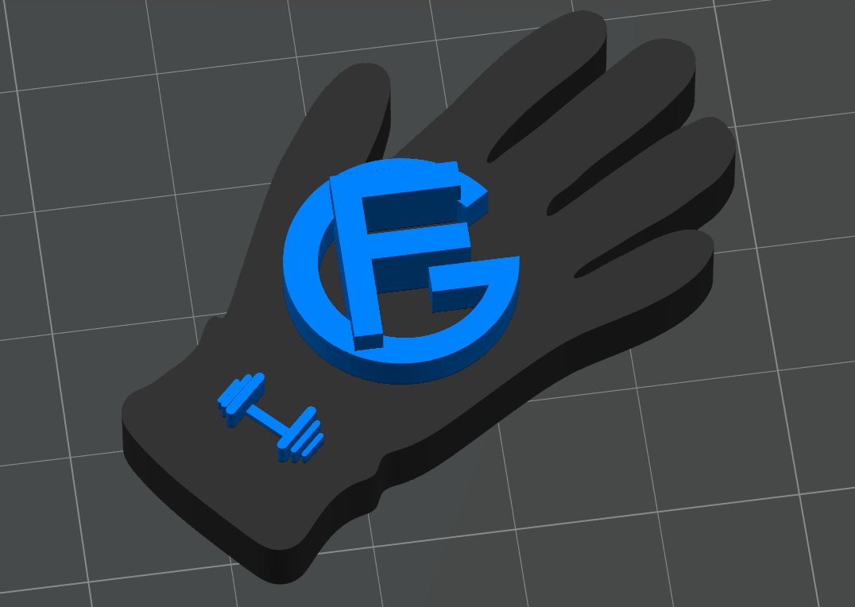

Figure 9: Logo in Bambu Studio

The PDI was completed fully, with the introduction explaining the purpose, background information, and goals behind the product. The resources section went into the physical construction, software setup, cost estimate, and project schedule of the product. Potential problems were identified in writing the PDI, such as the flexibility of the glove with all the circuitry, and were able to be considered early on in the design.

A preliminary CAD model of the Force Glove was submitted. The model had generic glove models, with a simple LCD screen model placed on the back of each glove, right below where the knuckles would be. A force sensor would be placed across the palm of the gloves (Figure 10). A circular case was placed separate from each glove, with a breadboard attached to the top of the case, an Arduino on the bottom, and a battery and bluetooth module on the sides (Figure 11).

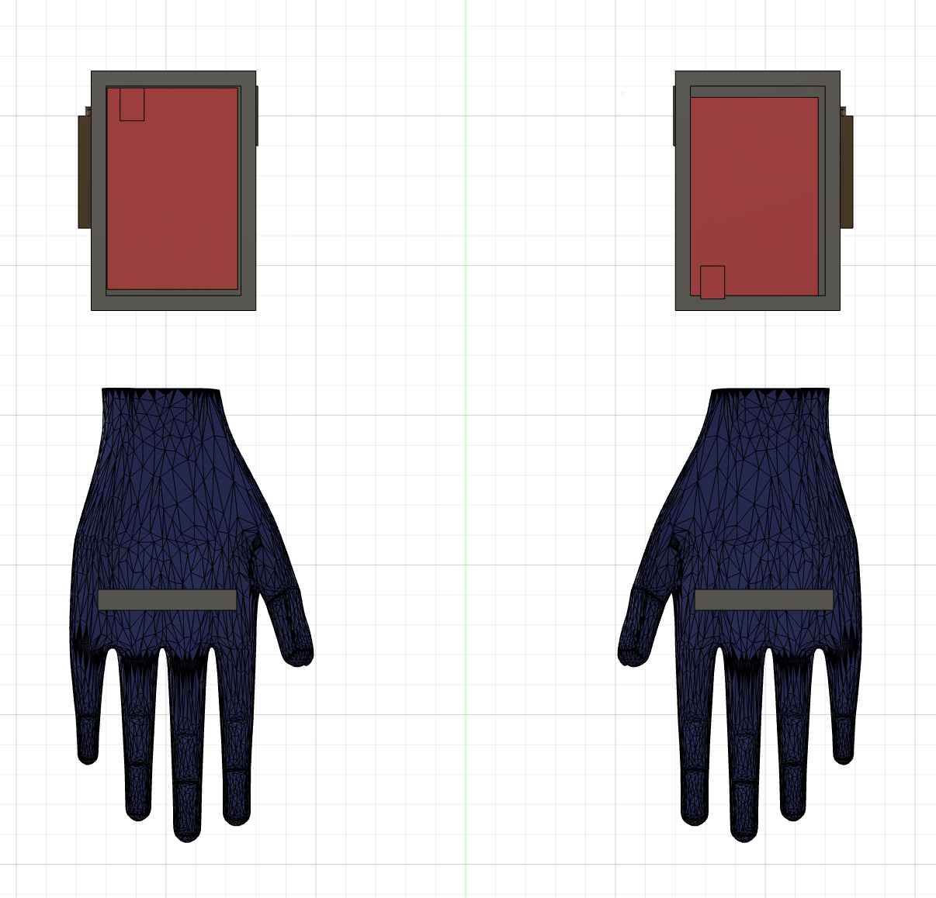

Figure 10: Preliminary CAD model of the Force Glove design (Bottom View)

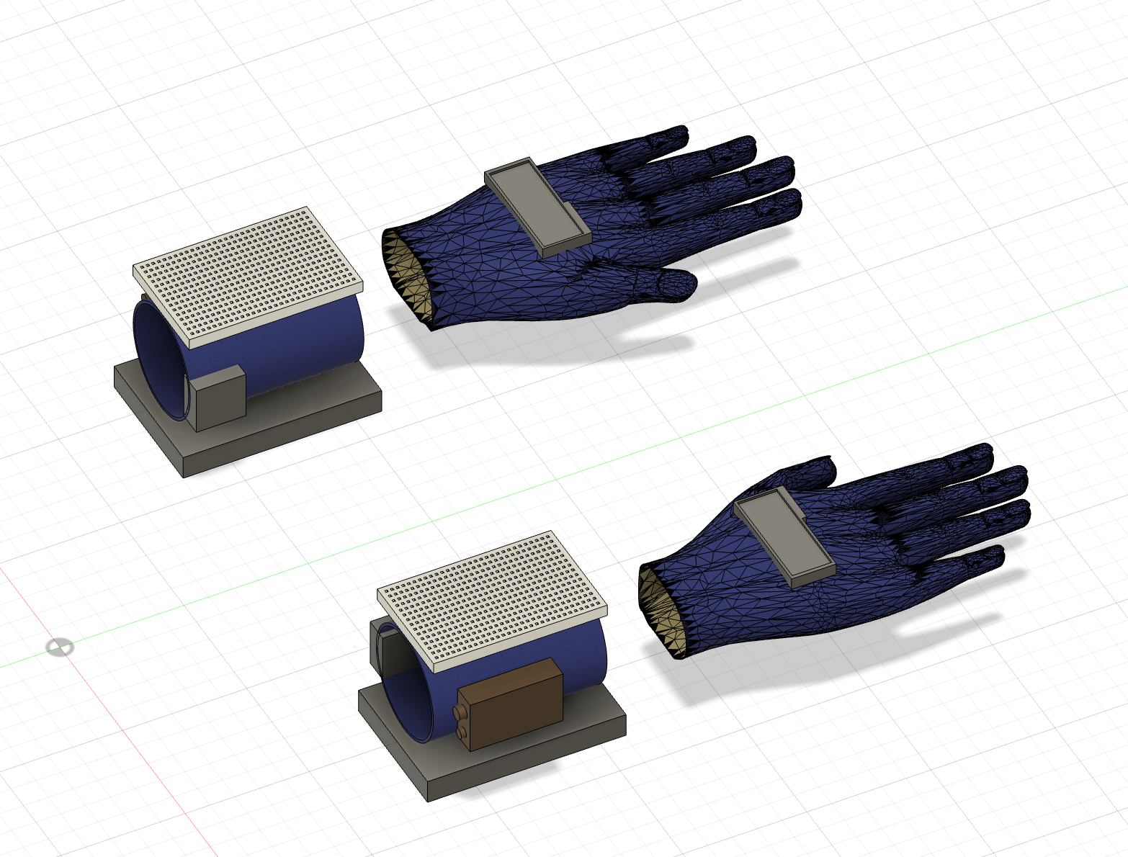

Figure 11: Preliminary CAD model of the Force Glove design (Isometric View)

The code flowchart was completed fully (Figure 7). After the components were initialized, with their respective libraries imported, a constant loop would run that compares the force sensed from each glove. As values are obtained from each sensor, if the sensors aren’t the same, a warning would be shown on the LCD display showing whether an arm needs more or less force, depending on which arm has more strength. When both values are the same, the values of strength would be shown on the LCD screens and then sent via bluetooth.

The circuit diagram was completed fully. The components shown include the 9V battery, LCD display, Arduino board, force sensor, and bluetooth module. All the wiring between the components was shown and kept neatly using the breadboard (Figure 12).

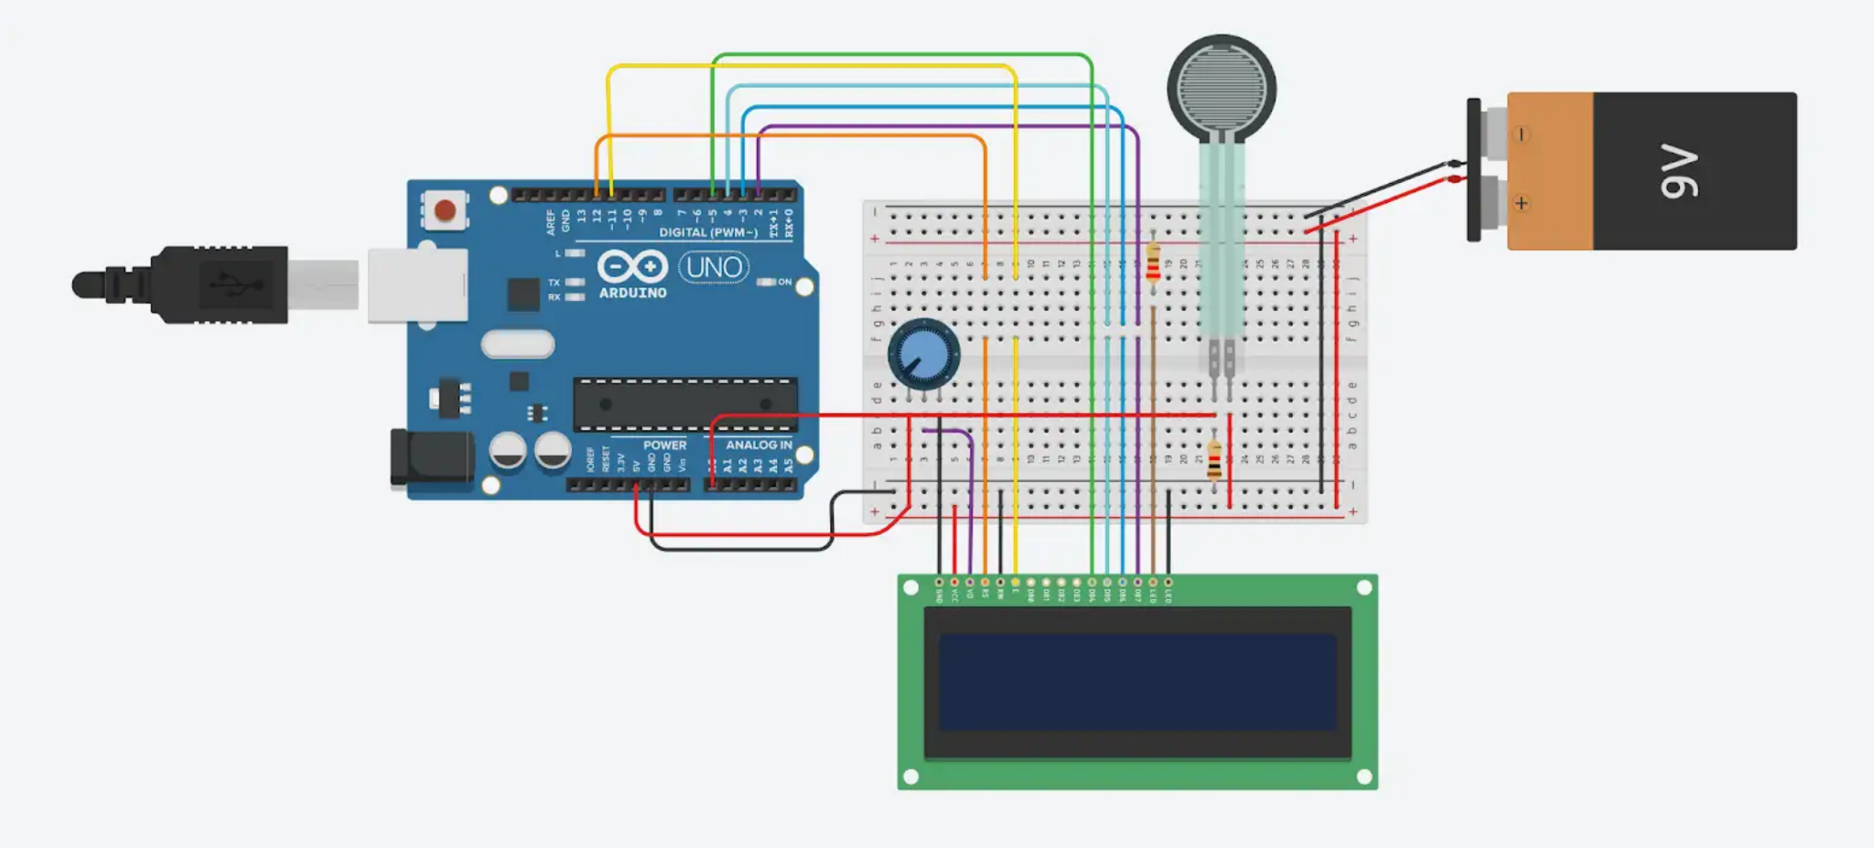

Figure 12: Circuit diagram for Benchmark A

The research for the different types of gloves was also completed. Two different types of gloves were found and had five detailed notes for each, allowing for one of the gloves to be chosen for the design.

All tasks for benchmark B were completed on time. The engineering notebook was updated with detailed entries until benchmark B. The logo was approved by a Protolab TA. The CAD model was updated to include a better depiction of the arm strap, increasing the length of the model to match its real life counterpart. The force sensor placement was also changed to be vertical rather than horizontal, as this design would allow for the gloves to work with more exercises (Figure 13). The housing for the circuitry was included on the arm strap, being placed at the top of the arm band, where the forearm would be. The breadboard was depicted to be laying inside the housing (Figure 14).

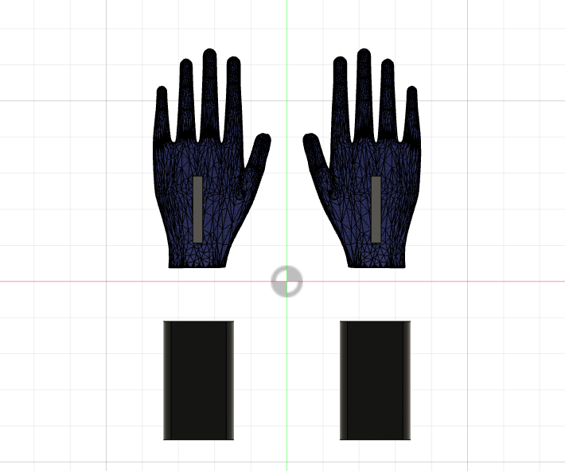

Figure 13: Bottom view of Benchmark B CAD model

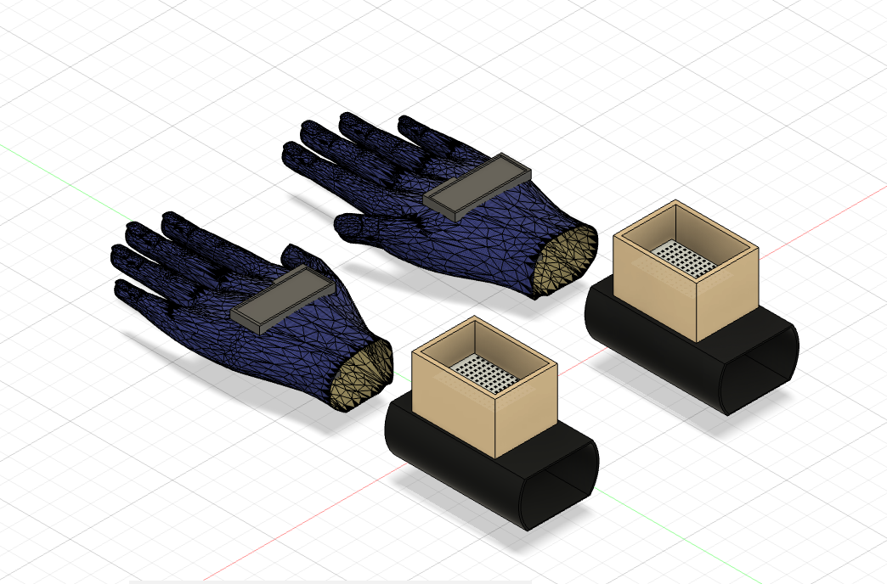

Figure 14: Isometric view of Benchmark B CAD model

Both circuits were assembled using the updated circuit diagram (Figure 15). The circuits were fully functional and able to display the force applied on the sensors onto the LCD displays. The brightness was adjustable for times when the screen was too bright or too low.

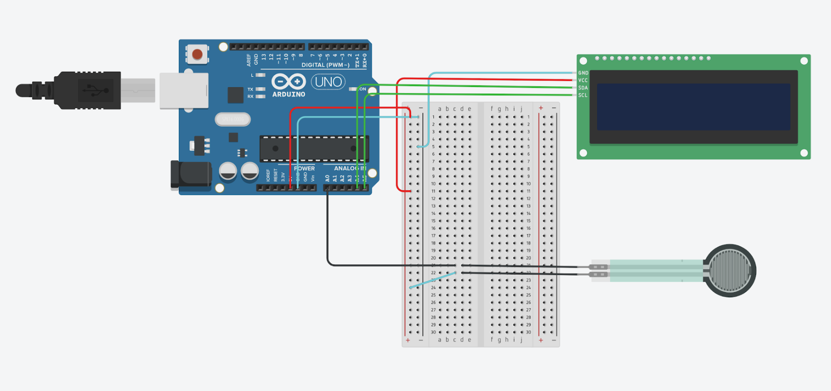

Figure 15: Benchmark B Circuit Diagram

The housing departments for the circuits were constructed. Each circuit was placed within the housing, with only the breadboard being placed on top of the housing temporarily. The housing matched the design shown in the CAD model.

The project schedule was completed in Microsoft Project and included twenty tasks, not including milestones. Each task was assigned to a group member, and each task was updated to show completion and progress. The milestones, benchmark dates, and progress lines were included as well (Figure 16).

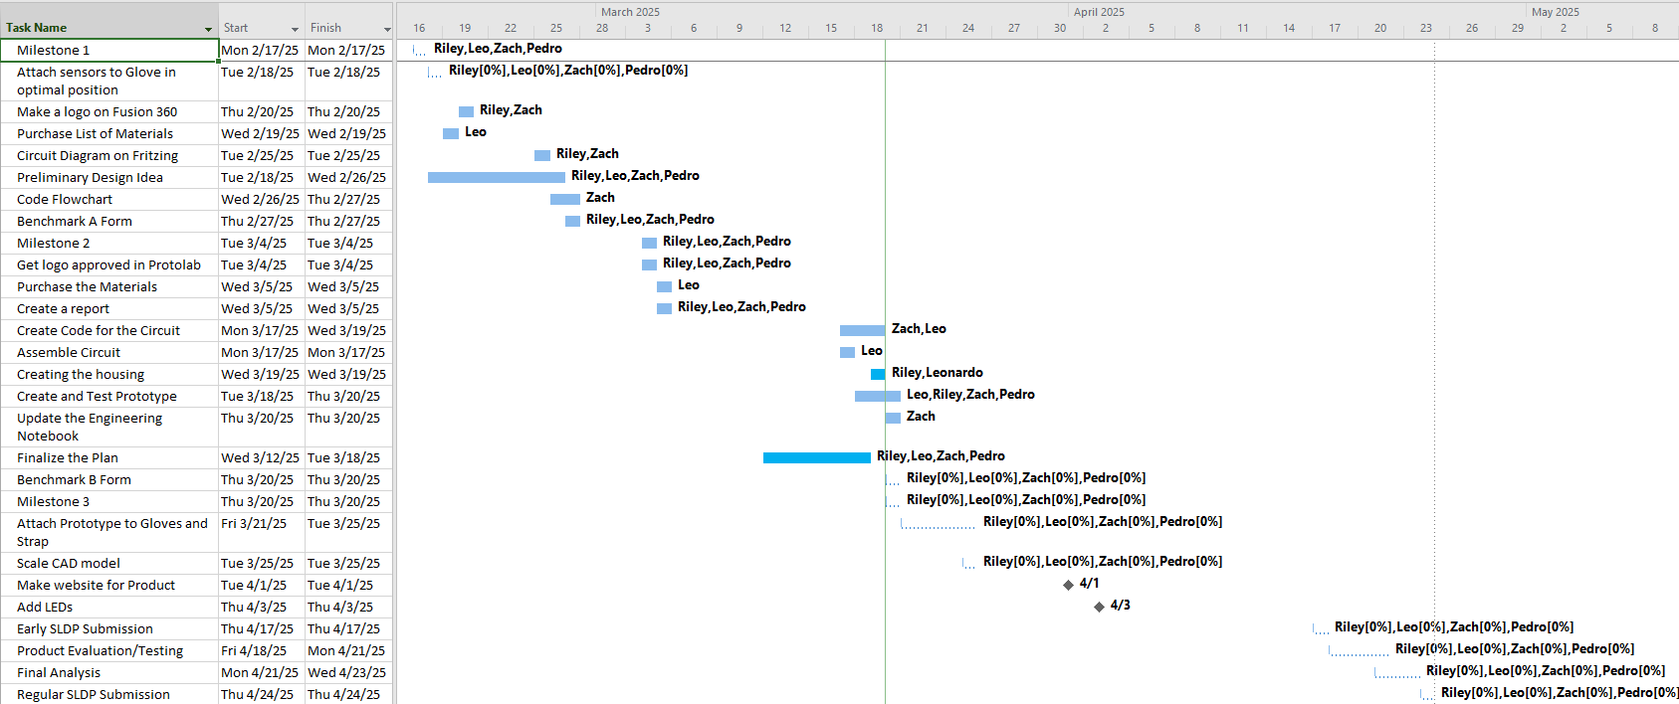

Figure 16: Project Schedule for Benchmark B

There were many difficulties encountered during the production of the product, most notably the bluetooth module. Although the bluetooth modules were wired correctly, no communication was ever able to be transmitted between them, which meant there was no way to transmit the sensor data from the gloves to each other. To solve this, the bluetooth module was swapped for another wireless module, consisting of a transmitter and a receiver. These modules worked and were able to transmit sensor data from one glove to another and allowed for the forces in each glove to be compared.

These new modules still provided difficulties in getting them to communicate with each other. One of the problems was the lack of strength between the transmitter and receiver, which was fixed by soldering the modules to make the signal stronger. Another problem was coding the modules, as it was difficult to even transmit a simple string message from the transmitter to the receiver. It took several hours to figure out how to code the modules.

Additionally, after a test trial in which the product worked, one of the Arduino boards stopped working. No code could be uploaded to it at all and it could not be reset. Different Arduino boards had to be connected to the wires and tried, but many other Arduino boards failed to receive the code from the lab computers. It took several uploads for one of the Arduino boards to receive the code and work again.

6. CONCLUSION

The Force Glove was a successful project, meeting all requirements and objective outlined

in initial and final iterations. The device was fully operational, integrating FSRs, LCDs,

and wireless module for communication to ensure the force being read from each arm was

comparable.

The physical construction of the device included a box and sleeve to allow for the components to be sturdy and stationary, preventing movement or damage to the parts during lifting. With regards to the software aspect of the project adjustments were made to the calibration of the FSRs to ensure the data being read was comparable as well as the LCDs potentiometer was adjusted to ensure the brightness of the LCD was adequate to display the readings.

In summary, the Force Glove exceeded expectations by providing a solution to muscle imbalance within working out. As the current market has no current products which provide this feature. The price of the Glove makes it accessible to all within the fitness industry at a cost of $153.35. Its design ensures that it does not disrupt comfort or output during a work-out making it feasible to carry and use during work-outs enhancing strength training.

For future iterations of the product, the design can be modified to ensure it is more compact and aesthetically pleasing by hiding all the wires so that users do not have to see or worry about the wiring of the glove.

7. WORKS CITED

One peloton. 2024 “4 Signs You have a Muscle Imbalance – And Exactly How to Fix It” Accessed February 27, 2025, from <https://www.onepeloton.com/blog/muscle-imbalance>

The National Library of Medicine “QuickStats: Percentage* of Adults Aged ≥18 Years Who Met the Federal Guidelines for Muscle-Strengthening Physical Activity,† by Age Group and Sex” Accessed February 27, 2025, from <https://pmc.ncbi.nlm.nih.gov/articles/PMC9098242/>

The National Library of Medicine “Prevalence and Pattern of Injuries Across the Weight-Training Sports”

Accessed February 27, 2025, from <https://pmc.ncbi.nlm.nih.gov/articles/PMC10689975/#:~:text=The%20study%20included%20393%20participants,injuries%20(2.3%25)%20were%20reported>.

My Protein “How Much Do Americans Spend On Health & Fitness?” Accessed February 27, 2025, from <https://us.myprotein.com/thezone/training/much-americans-spend-health-fitness-survey-results-revealed/>